UiPath Generative Extractor Workflow – Step-by-Step Guide
1. Reuse the earlier UiPath Studio Workflow
- Use the UiPath Studio Workflow from “Structured Documents module”
- Open the Main workflow.
2. Configure Document Inputs
- Place sample documents in the Data ->Input folder.
3. Configure the Taxonomy
- Open Taxonomy Manager.
- Create the required document types:
  - Group - Certificates
  - Category - Forms
  - Document Type -Degree_Cert
- Create 3 field
  - UniversityName (type: Text)
  - AwardeeName (type: Text)
  - DateofDegree (type: Date)
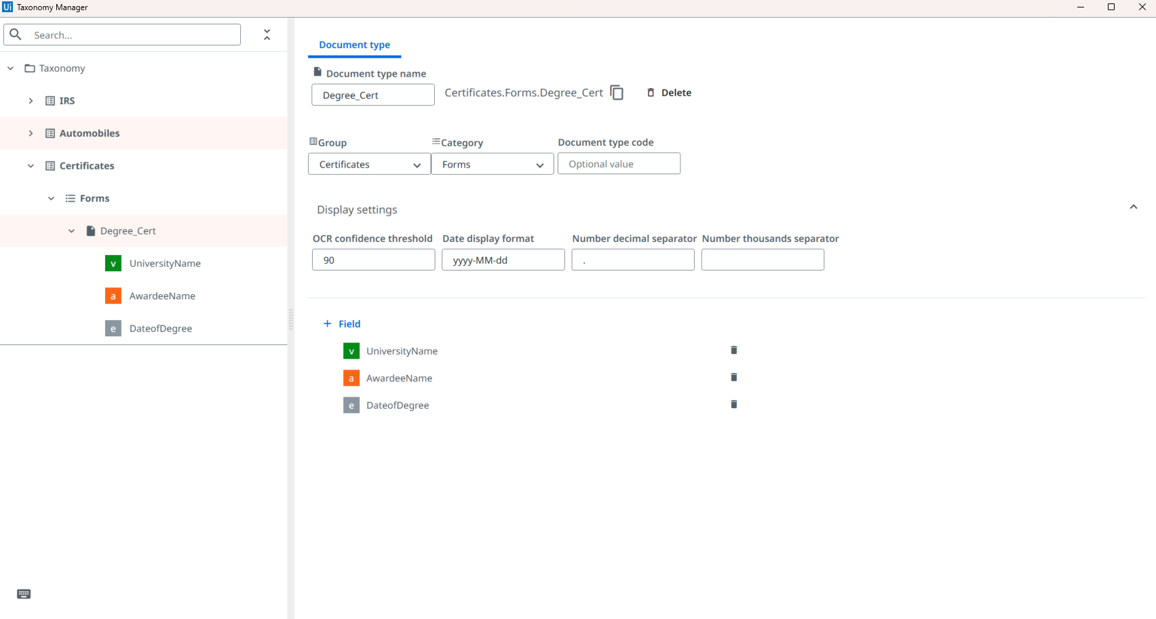
- Save the taxonomy.
4. Add a Generative Classifier
- Under the Classify Document Scope in the workflow.
- Add:
  - Generative Classifier
- Click Manage Field Details on the Generative Classifier.
- For Degree_Cert document type, provide a natural-language description and Save.
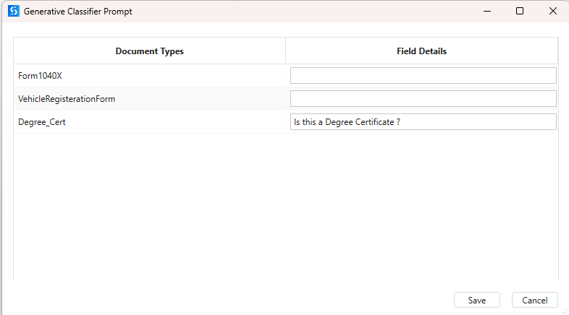
Example:
  - Degree_Cert → "Is this a Degree Certificate?"
- Click on Configure classifier and save below configuration.
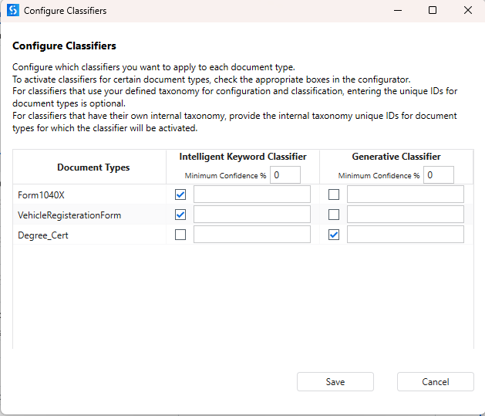
5. Configure a Generative Extractor
- Under the Data Extraction Scope in the workflow.
- Add:
  - Generative Extractor
- Click Manage Field Details on the Generative Extractor.
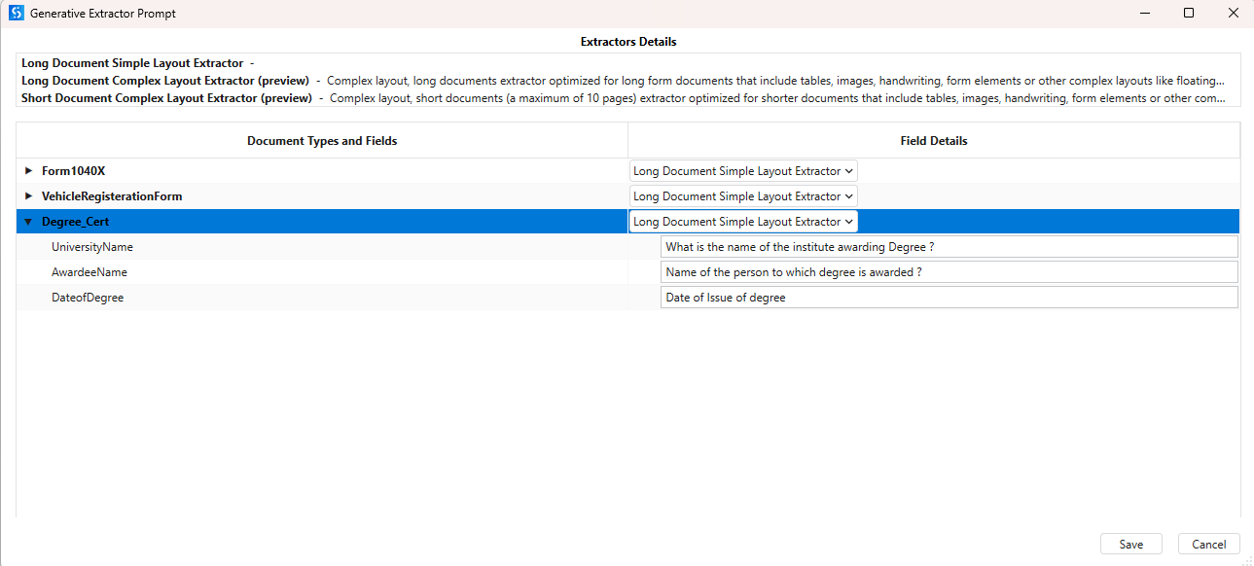
UniversityName: What is the name of the institute awarding Degree?
AwardeeName: Name of the person to which degree is awarded?
DateofDegree: Date of Issue of degree

- Save.
- Click on Configure Extractor.
- Do below configuration and Save.
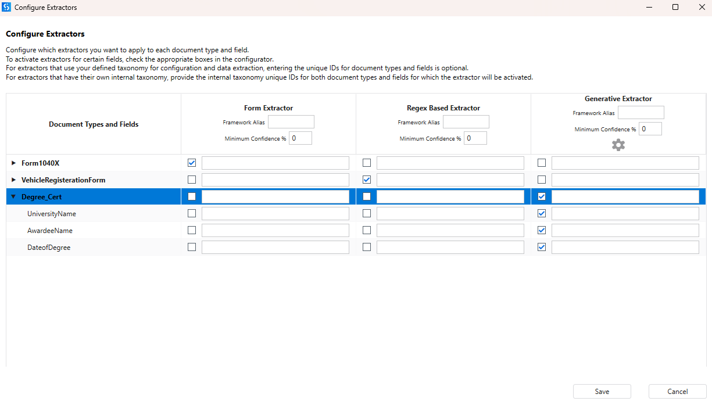
8. Execute Extraction
- Run the workflow.
- Observe Output logs.
- Verify:
  - Taxonomy loaded successfully.
  - Classification completed.
  - Extraction completed.
  - Extracted fields are returned.
9. Validate Extraction Results
- Add Present Validation Station after extraction.
- Review extracted values.
- Correct any incorrectly extracted fields.
- Submit validation results.

